**\*categorize by methods and models**

**Mir, A. A., Alghassab, M., Ullah, K., Khan, Z. A., Lu, Y., & Imran, M. (2020). A review of electricity demand forecasting in low and middle income countries: The demand determinants and horizons. *Sustainability*, *12*(15), 5931.**

1. **Objectives**
   1. Given the global increasing electricity demand, this research aims to understand the insights of load forecasting techniques for projecting future electricity demands.
   2. Having a forecasted load for appliances, range from energy generation, energy management at different nodes and sectors, energy pricing and many others, is to ensure a safe, reliable and affordable energy supply.
2. **Methods and Data**
   1. Literature review. Reviewed and analyzed a total of 69 research articles from 16 different countries (including Pakistan), published over the period of last twenty years (2000–2020)
3. **Results** 
   1. Forecasting horizons
      1. Based on their forecasting horizons, electricity load forecasts can be broadly categorized into three distinct categories: short term load forecasting (STLF), medium term load forecasting (MTLF), long term load forecasting (LTLF).
         1. STLF
            1. Time period: ranging from hours to days or weeks ahead
            2. Purpose: facilitating electricity markets for the day ahead planning of the electricity supply and in demand side management
         2. MTLF
            1. Time period: months to years ahead
            2. Purpose: help in revenue assessments, unit maintenance scheduling, and energy trading etc
         3. LTLF
            1. Time period: 5-10 years ahead
            2. Purpose: provide a deeper insight for policy makers and help with the efficient management of assets and e effective power systems expansion planning.
         4. Load forecasting applications over different time horizons   
            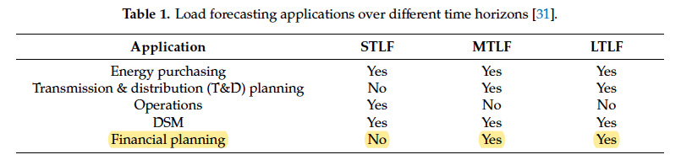
   2. Forecasting techniques

|  |  |  |  |
| --- | --- | --- | --- |
| Techniques | Approach | Pros | Cons |
| Bottom-up models | produce forecasts at the customer/device level and then sum it up across  different customers/devices to a higher aggregation level | Incorporate the detailed load data | Does not consider the macroeconomic impacts of long-term energy policies and are often considered less suitable for long-term forecasting |
| Top-down approach | produce demand projections at the consumption group level by aggregating customers into larger groups | Incorporate information pertaining to the economic growth, which is helpful for understanding the impacts of energy policies on a region’s economy | Does not include technological aspects, and thus lack in providing information on technological progress |
| Regression analysis | Produce the forecast parameters | allows to develop a statistical  relationship between the dependent and independent variables | Lack at capturing non-linearity of data |
| Time series forecasting techniques | make use of a trend analysis to predict future values | it can be non-reliant on the demand determinants for making reliable forecasts by using time series  techniques such as the autoregressive integrated moving average (ARIMA) or exponential smoothing | A load time series  is a pattern of measured values of load, exhibiting daily, weekly, and seasonal periodicities  , and thus cannot be relied upon to gain insight on the electric load and its determinants for a specific utility and time frame |
| Artificial intelligence-based techniques | Learn from given historical data patterns and develop relationships between the input variables and forecasted load |  | Lack in providing the relationship between the electricity demand and its determinants |
| Additive models | Incorporate non-linearity between dependent and independent variables | Allowed to have non-linear and non-parametric terms in a regression framework have shown to find complex relationships between the electric load and its determinants | Depends on the available data and related constraints |

* + 1. Time series modeling approach has been extensively used while forecasting for long and medium terms. For short term forecasting, artificial intelligence-based techniques remain prevalent in the literature.
    2. Artificial intelligence-based forecasting techniques have mostly been used by forecasters, followed by time series modeling
  1. The electricity demand trends are different for both developed and developing economies. With increasing economic activity, the inclusion of economic variables in the forecasting models become paramount.

1. **Others** 
   1. Increased the penetration of renewable resources and new technologies at customer dies (electric vehicles, energy storage), those technological advancements are changing the shape of the grid from demand-driven power system to a generation power driven system.
   2. Demand determinants
      1. Economic index: GHG emissions,
      2. Environment: weather variables. fuel cost
      3. Electricity: energy intensity, environmental emission factors, technological progress, load data, electricity consumers growth
   3. Artificial neural network (ANN)
      1. learn from given historical data patterns and develop relationships between the input variables and forecasted load
      2. lack in providing the relationship between the electricity demand and its determinants
   4. Fuzzy logic (FI)
      1. Determines a more vivid relationship between the dependent and independent variables
      2. Dealing with a scarce number of observations, hence it is compatible working with comparatively smaller data set and error distribution verification processes

**Bedi, J., & Toshniwal, D. (2019). Deep learning framework to forecast electricity demand. *Applied energy*, *238*, 1312-1326**

1. **Objectives** 
   1. With increased electricity demand, the utility companies are responsible for facilitating better plans and maintaining energy consumption database to improve their services continuously.
   2. Modeling of non-linear electricity demand patterns is still underdeveloped for robust solutions as the existing methods are useful only for handling short-term dependencies
2. **Methods and Data**
   1. Data: the electricity consumption data of Union Territory Chandigarh, India
   2. LSTM based deep learning framework, which could
      1. Handle the nonlinear complex behavior of electricity consumption pattern
      2. The existing methods are purely external features driven. So the predictive model should be able to forecast demand from the minimum available historic data only
      3. The proposed model needs to be adaptive and it should support active learning
   3. deep learning based framework (D-FED) 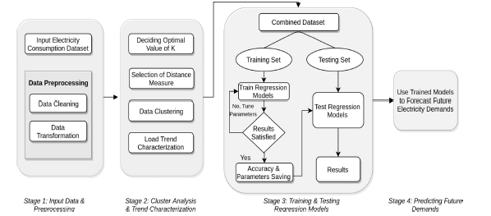
      1. Data Cluster: K-means is used to cluster distance measures – euclidean distance, DTW distance, and LB Keogh distance. Elbow curve method is used to determine an optimal k value which will produce the best clustering results. A plot of k-values versus SSE is generated to select optimal value of k.
      2. Load trend characterization is done at daily, seasonal, periodical, and total consumption levels to capture a deeper understanding if the behavior of electricity patterns.
      3. Build 4 regression – SVM, ANN, RNN, LSTM, to predict future demand of the Union Territory Chandigarh. The training model is based on LSTM network moving window-based technique, and use SVM, ANN, RNN to carry out performance comparison.
   4. Data source: electricity demand data of UT sampled at a regular interval of 15 min for a lustrum starting from January 2013
3. **Results** 
   1. The D-FED can handle non-linear complexities, short-term and long-term dependencies of the electricity consumption time series data, and has minimum prediction errors.
   2. The D-FED is adaptive and provides support for active learning. In addition, it can be generalized to estimate demand for other demographic locations.
4. **Others** 
   1. Things that are need to be considered while building a prediction model
      1. Hyper-parameters selection
      2. Optimization technique and loss function
      3. Evaluation measures

**Jiang, P., Li, R., Lu, H., & Zhang, X. (2020). Modeling of electricity demand forecast for power system. *Neural Computing and Applications*, *32*, 6857-6875.**

1. **Objectives**
   1. The real-time scheduling of electricity generation needs accurate modeling of electricity demand forecasting for a range of lead time. This paper aims to better capture the nonlinear and non-stationary characteristics and the seasonal cycles of future electricity demand data.
2. **Methods and Data**
   1. Use integrated model (AFD-S-OLSSVM) 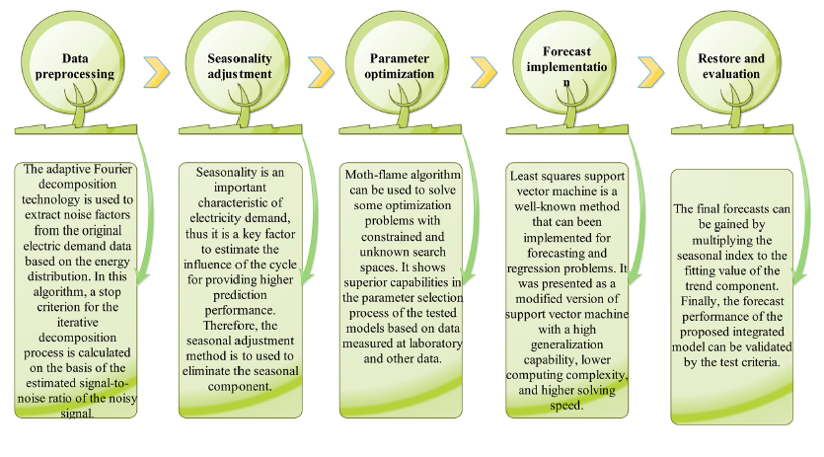
      1. Data processing model: adaptive Fourier decomposition, used to separate a signal with noise by overlapping frequency range
      2. Seasonal component adjustment: to address the seasonality that existed in the original data
   2. Parameters optimization module: Moth-flame optimization technique, used to solve optimization problems with constrained and unknown search spaces
   3. Forecast module: Least squares support vector machine, used to capture the nonlinear patterns hidden in the power
   4. Restore and evaluation module: multiply the seasonal index to the forecasting value of the trend component in order to obtain the ultimate forecasts
   5. Data source: electricity demand in South Australia, Feb 1st – Feb 28th, 2014. The time gap of observation series is half an hour, which means 1 day has 48 observation values
3. **Results** 
   1. The nonlinear and non-stationary characteristics can be captured by input variable preprocessing model.
4. **Others**
   1. This paper mainly focuses on short-term electricity demand, and thus the methods might not be applicable for long-term prediction.

**Qiu, X., Ren, Y., Suganthan, P. N., & Amaratunga, G. A. (2017). Empirical mode decomposition based ensemble deep learning for load demand time series forecasting. *Applied soft computing*, *54*, 246-255.**

1. **Objectives** 
   1. Forecasting results with high accuracy can be effective to predict the potential faults in the power system, and thus provide a reliable safety basis for the grid operation.
2. **Methods and Data**
   1. The electricity load demand data sets from Australian Energy market Operator (AEMO) are used to test the effectiveness of the proposed EMD-based DBN approach.
   2. Two forecasting horizons are adopted for comparison: half an hour and one day ahead
   3. Proposed an ensemble deep learning method based on EMD and DBN. Nine benchmark methods have been compared to verify the effectiveness of the proposed method: Persistence, SVR, ANN, DBN, RF, EDBN, EMD-SVR, EMD-SLFN, and EMD-RF. Two error measures were used to evaluate the performance of these prediction models.
      1. Persistence: assumes that the conditions at the future time of forecast are the same as the current values.
3. **Results** 
   1. Empirical Mode Decomposition based methods outperform the single structure models
   2. Deep learning shows more advantages when the forecasting horizon increases
   3. Random forest is effective for load demand forecasting with the advantage of fast training.
   4. Deep learning algorithms show their advantages in dealing with nonlinear features when the forecasting horizon increases.
   5. The persistence method works well for very short-term load demand forecasting since the temperature and human factors change little during a short time period. Therefore, persistence method can be treated as a baseline for evaluating the effectiveness of machine learning models.
   6. EMD-DBN model has the best performance for half-an-hour ahead forecasting in most cases
4. **Others**
   1. Basic intro of models
   2. Methods of time series analysis can be divided into two categories: univariate and multivariate. Kolmogorov-Smirnov statistical hypothesis test is applied for univariate TS, and the Hotelling T-Squared multivariate statistical hypothesis test is used in the case of multivariate TS.
   3. In the recent years, with the rapid development of computational intelligence, artificial neural network (ANN), fuzzy comprehensive evaluation and support vector machine (SVM) methods have been widely used for short-term load forecasting. ANN has been successfully applied in the fields of classification and regression, but still fell out of fashion as it often trapped in a local minimum.

**Amini, M. H., Kargarian, A., & Karabasoglu, O. (2016). ARIMA-based decoupled time series forecasting of electric vehicle charging demand for stochastic power system operation. *Electric Power Systems Research*, *140*, 378-390.**

1. **Objectives** 
   1. Demand forecast is usually designed for the seasonally changing load patterns. However, with the high penetration of EVs, daily charging demand makes traditional forecasting methods less accurate. This paper present a chance-constrained day-ahead scheduling problem.
2. **Methods and Data**
   1. Flow chart   
      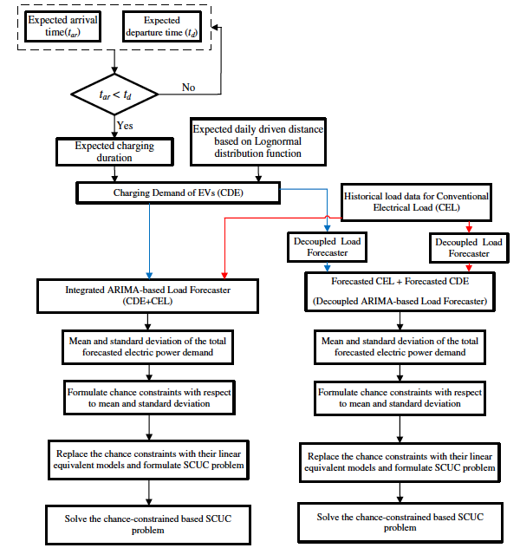
   2. Use antoregressive integrated moving average (ARIMA) method for demand forecasting of conventional electrical load (CEL) and charging demand of EV (CDE) parking lots simultaneously.
   3. Take daily driving patterns and distances as an input to determine the expected charging load profiles. The parameters of the ARIMA model are tuned so that the mean square error (MSE) of the forecaster is minimize.
   4. The forecaster outputs are used to formulate a chance-constrained day-ahead scheduling problem to show the potential cost saving benefits of the proposed forecaster in the security constrained unit commitment (SCUC) problem.
3. **Results** 
   1. the proposed forecaster with decoupled approach reduces the daily operating costs by almost 2.9% for the 6-bus test system and 23% for the IEEE-24 bus test system for the simulated scenario compared with the integrated forecasting approach. This can potentially lead to a considerable annual cost saving of $770k for the 6-bus system and $240M for the IEEE-24 bus system. Thus, when scaled, our demand forecasting approach might help achieve significant cost savings in stochastic power system operations.
4. **Others**

**Bedi, J., & Toshniwal, D. (2018). Empirical mode decomposition based deep learning for electricity demand forecasting. *IEEE access*, *6*, 49144-49156.**

1. **Objectives** 
   1. How to handle complex nonlinear relationships and long term historical dependencies present in the data.
   2. An effective way to combine EMD with deep learning algorithm (LSTM) for noise-free data training.
   3. An efficient way to provide support for dynamic learning with the help of deep LSTM network models
2. **Methods and Data**
   1. Diagram  
      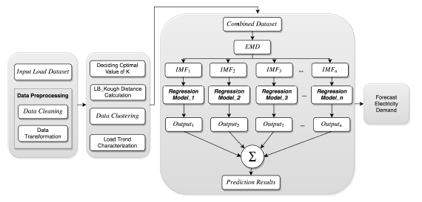
   2. Combined the EMD methods with the long short-term memory network model to estimate electricity demand for the given season, day, and tome interval of a day. EMD is a nonlinear analysis approach for non-stationary time series data.
   3. Electricity data: Chandigarh, a city in India. The consumption data is recorded every 15 minutes, which means there are 96 data points for one day.
   4. Data analysis
      1. Data processing
         1. Replace missing value with the mean electricity consumption value of that month
         2. Data aggregation: combine consumption files with different formats into a single usable format
         3. Data transformation: subtract the mean value of a time series from each timestamp value of that time series signal
      2. Data clustering
         1. Use K-means clustering algorithm to find out the group of months in the electricity data that follows similar consumption patterns
         2. Use Elbow methods to determine the value for parameter k
   5. To predict average and peak electricity demand for the season, day, and time intervals specified by the user, load characterization is performed at two different levels.
      1. Seasonal analysis: Spring, Autumn, Monsoon
      2. Daily/time-span analysis: 00-06; 06-12; 12-18; 18-24
   6. Train 12 LSTM network models to estimate future electricity demand for the user specified time interval. The average and peak demand prediction results of the proposed (EMD+LSTM) approach are compared with RNN, EMD based RNN (EMD+RNN) and LSTM models. The performance of the models is measured by RMSE and absolute percentage error.
3. **Results** 
   1. EMD+LSTM outperforms other regression models for electricity demand time series forecasting
   2. AI-based techniques were found to be most promising while capturing nonlinear variations of data. However, these techniques are not capable of handling historical data dependencies.
4. **Others**
   1. Several machine learning algorithms such as Support Vector Machine (SVM), Decision trees, Artificial Neural network (ANN), Recurrent Neural Network (RNN) have been used by the researchers for electricity demand forecasting. Even though in the recent years, various hybrid models have also gained a lot of interest to improve overall prediction accuracy, there is still a need for more robust solutions to analyze and forecast the electricity load patterns effectively.

**Deb, C., Zhang, F., Yang, J., Lee, S. E., & Shah, K. W. (2017). A review on time series forecasting techniques for building energy consumption. *Renewable and Sustainable Energy Reviews*, *74*, 902-924.**

1. **Objectives**
2. **Methods and Data**
   1. over 113 different case studies reported across 41 paper
3. **Results** 
   1. The regression models are still widely used and efficient for long and very long-term prediction. For short and very short-term prediction, machine-learning algorithms such as artificial neural networks support vector machines, and time series analysis (including ARIMA and ARMA) are favored.
   2. Short term predictions require more sophisticated models such as machine learning or ARIMA because the variables interrelationships are more complex and sensitive on this time scale. Ann has been implemented with a relatively large range of variables which indicates flexibility of the models toward the data introduced as inputs (environmental, building and time index)
   3. The regression models have been mainly set up with socio-economic inputs.
   4. None of the model clearly outperforms the others and seeking the most accurate is meaningless in this case. Instead, this study assumes that the most commonly used practices by the expert community are representative of the best use of forecasting models.
4. **Others**
   1. ANN has been used for various tasks such as (a) short-term load forecasting (STLF) in microgrids (b) optimization scenarios at building level, and (c) long term horizon scenarios to determine annual electricity consumption of a region, district or building.

**Vu, D. H., Muttaqi, K. M., & Agalgaonkar, A. P. (2015). A variance inflation factor and backward elimination based robust regression model for forecasting monthly electricity demand using climatic variables. *Applied Energy*, *140*, 385-394.**

1. **Objectives** 
   1. To understand how different climate variables, such as temperature, humidity, and rainy days, may have different impacts on the electricity demand due to the varying geographical conditions
2. **Methods and Data**
   1. diagram  
      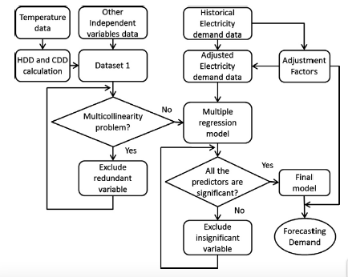
   2. Use multicollinearity and backward elimination processes to select the most appropriate variables
   3. develop a multiple regression model for monthly electricity demand forecasting.
   4. Data: the monthly electricity demand data and temperature data for 12 years from year 1999–2010 for the state of New South Wales (NSW), Australia. The dataset are available or every half an hour and has been collated on daily and monthly basis for the proposed studies.
3. **Results** 
   1. The socioeconomic variables such as population, gross state product, and electricity price are expected to have strong influence on the electricity demand
   2. Among all climatic variables, temperature is reported to be the most important variable that can have significant impact on the electricity demand. Wind speed, humidity, evaporation, rainfall, rainy days, solar exposure, and sunshine hours may have linear relationship with the electricity demand.
   3. The electricity demand predominantly depends on the CDD, HDD, humidity, and the number of rainy days.
   4. The multicollinearity analysis helps to eliminate the variables which are highly related to the other independent variables from the dataset, and the backward elimination regression analysis excludes the insignificant variables from the model.
4. **Others**
   1. The neural network and Kalman filter application are claimed to be sufficiently efficient in short-term forecasting, and the multiple linear regression model is widely used for long-term demand forecasting or medium-term forecasting

**Massaoudi, M., Chihi, I., Sidhom, L., Trabelsi, M., Refaat, S. S., & Oueslati, F. S. (2019). A novel approach based deep RNN using hybrid NARX-LSTM model for solar power forecasting. *arXiv preprint arXiv:1910.10064*.**

1. **Objective**
2. **Methods and data** 
   1. Propose a hybrid method for non-stationary time series prediction composed of LSTM cells and NARX networks, targeting the PV power forecasting in medium/long-term dependencies
   2. NARX network received the weather information to primarily predict the PV power. The predicted PV power is added to the original database to pass to LSTM-RNN. The output of the aforementioned model presents the final result.  
       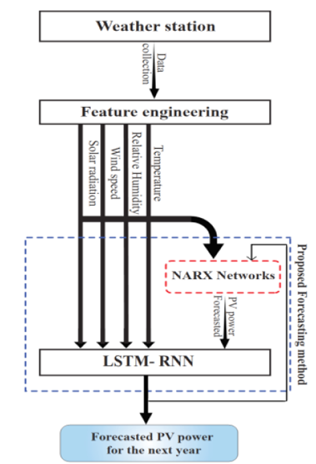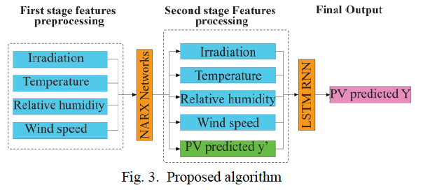
   3. Data
      1. Time period: historical data, 04/01/2016 - 04/01/2018; forecasting outputs, 04/01/2018 - 04/01/2019
      2. Inputs: ambient temperature, wind speed, irradiation, and relative humidity
3. **Results** 
   1. NARX-LSTM network is the most accurate in terms of RMSE
4. **Others** 
   1. Hybrid models are a combination of two or more prediction models, which enhance accuracy since the feature of each model will be transferred.

**Jurado, S., Nebot, À., Mugica, F., & Avellana, N. (2015). Hybrid methodologies for electricity load forecasting: Entropy-based feature selection with machine learning and soft computing techniques. *Energy*, *86*, 276-291.**

1. **Objective** 
   1. To demonstrate the performance of these models and their scalability for different consumption profiles
2. **Methods and data** 
   1. Compare the prediction accuracy of random forest, neural network, fuzzy inductive reasoning, and AutoRegressive Integrated Moving Average (ARIMA) 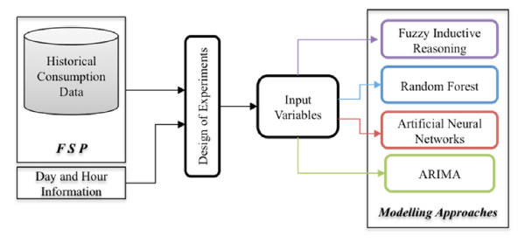
   2. Data
      1. Hourly electricity consumption in three building of the University Politecnica de Catalunya
      2. Three functional zones with different profiles of usage and locations are used in the experiments to demonstrate the scalability of the models in any type of building
      3. Time period: 11/13/2011 - 11/12/2012
   3. Use normalized mean square error to evaluate the forecasted results
3. **Results** 
   1. Random forest, neural networks, and fuzzy inductive reasoning are proposed to perform short-term electric load forecasting (24h)
   2. FIR is the methodology that performs a better forecast followed by the RF and the NN. However, in several cases RF is better than FIR.
4. **Others**

**Sanstad, A. H., McMenamin, S., Sukenik, A., Barbose, G. L., & Goldman, C. A. (2014). Modeling an aggressive energy-efficiency scenario in long-range load forecasting for electric power transmission planning. *Applied Energy*, *128*, 265-276.**

1. **Objective** 
   1. **T**o understand how will end-use energy efficiency affect econometric and technological elements to meet the load needs.
2. **Methods and Data**
   1. Use SAE framework to disaggregate the different impacts of energy efficiency on peak demand   
       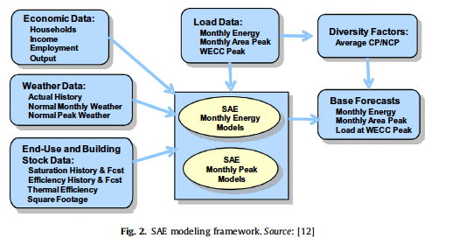
3. **Results**
4. **Others**
   1. Demand modeling and forecasting system
      1. California Energy Commission
      2. U.S. Energy Information Administration’s (EIA) National Energy Modeling System (NEMS)
   2. Regional transmission expansion projects

**Wang, J., Yang, W., Du, P., & Li, Y. (2018). Research and application of a hybrid forecasting framework based on multi-objective optimization for electrical power system. *Energy*, *148*, 59-78**.

1. **Objectives** 
   1. To increase accuracy and dependable stability of electrical power system forecasting
2. **Methods and data** 
   1. Proposed multi-objective dragonfly algorithm (MODA)
   2. Data processing
   3. Optimization
   4. Forecasting
   5. Evaluation
3. **Results**
4. **Others**
   1. Summary of reviewed forecasting models   
       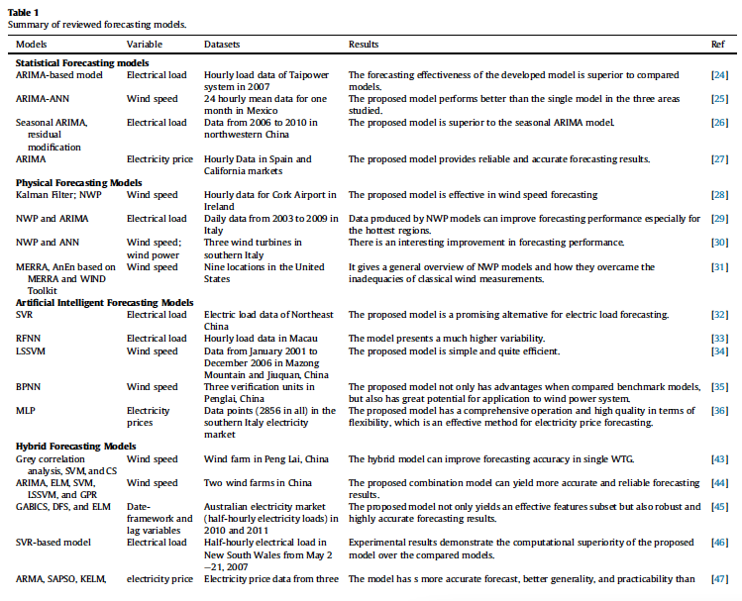

**Singh, P., Dwivedi, P., & Kant, V. (2019). A hybrid method based on neural network and improved environmental adaptation method using Controlled Gaussian Mutation with real parameter for short-term load forecasting. *Energy*, *174*, 460-477.**

1. **Objectives** 
   1. Artificial neural network seems more effective and capable to handle the non-linear behavior of load and generates and accurate forecast. However, it suffers from overfitting problem thus reducing the accuracy of load forecasts.
2. **Methods and data**
   1. Introduce a hybrid methodology to increase the accuracy of load forecasting by integrating an ANN training task with an enhanced optimization algorithm termed as IEAMCGM-R to determine ANN parameters 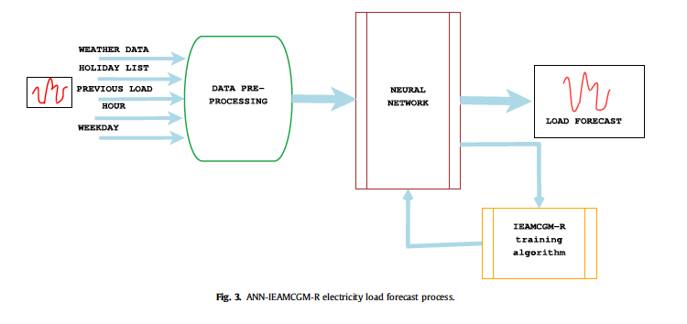
   2. Data
      1. Data from New England Power Pool (NEPOOL, ISO New England) and Australian Energy Market Operator (New South Wales, Australia) to validate the effectiveness of the proposed hybrid model
      2. Training sample: 2004 to 2007; testing sample: 2008 to 2009
      3. Input: temperature, rainfall, wind speed, holiday
3. **Results** 
   1. ANN-IEAMCGM-R outperformed other algorithms (ANN-IEAM-R, ANN-Jaya, ANN-IEAMGM-R, and ANN-IEAMCGM-R) in terms of forecasting accuracy and generalization ability
   2. Input parameter: hour of the day, day of the week, 168-hour lagged load, 24-hr lagged load, previous 24-hr average load
4. **Others** 
   1. **T**he layers of ANN; training sample and testing sample
   2. Structural risk minimization principle of Support Vector Machine (SVM) provides better generalization ability and solves stagnation problem. However, the main disadvantage of SVM is a high dependency between forecasting accuracy and selected SVM parameters
      1. Traditional ANN depends upon the initial parameters which lead to under-fitting or overfitting problems. In the past few years, researcher have combined ANN with various population-based optimization learning algorithm for adjusting network structure and network parameters in order to enhance the accuracy of load forecast.